Ideation Phase
Brainstorm & Idea Prioritization Template

Date | 08 December 2025
Team ID
Project Name | Freelance Finder
Maximum Marks | 4 Marks

Brainstorm & Idea Prioritization Template:
Brainstorming creates an open space where team members can freely share their thoughts and contribute creative ideas toward solving a problem. It focuses on collecting as many ideas as possible, encouraging unique and imaginative suggestions. Everyone works together, supporting and building on each other’s ideas to generate a wide range of possible solutions.
This template can be used during brainstorming sessions to help your team explore concepts, think creatively, and develop ideas—whether you're in the same place or collaborating remotely.
.
Reference: https://www.mural.co/templates/brainstorm-and-idea-prioritization

Step-1: Team Gathering, Collaboration and Select the Problem Statement

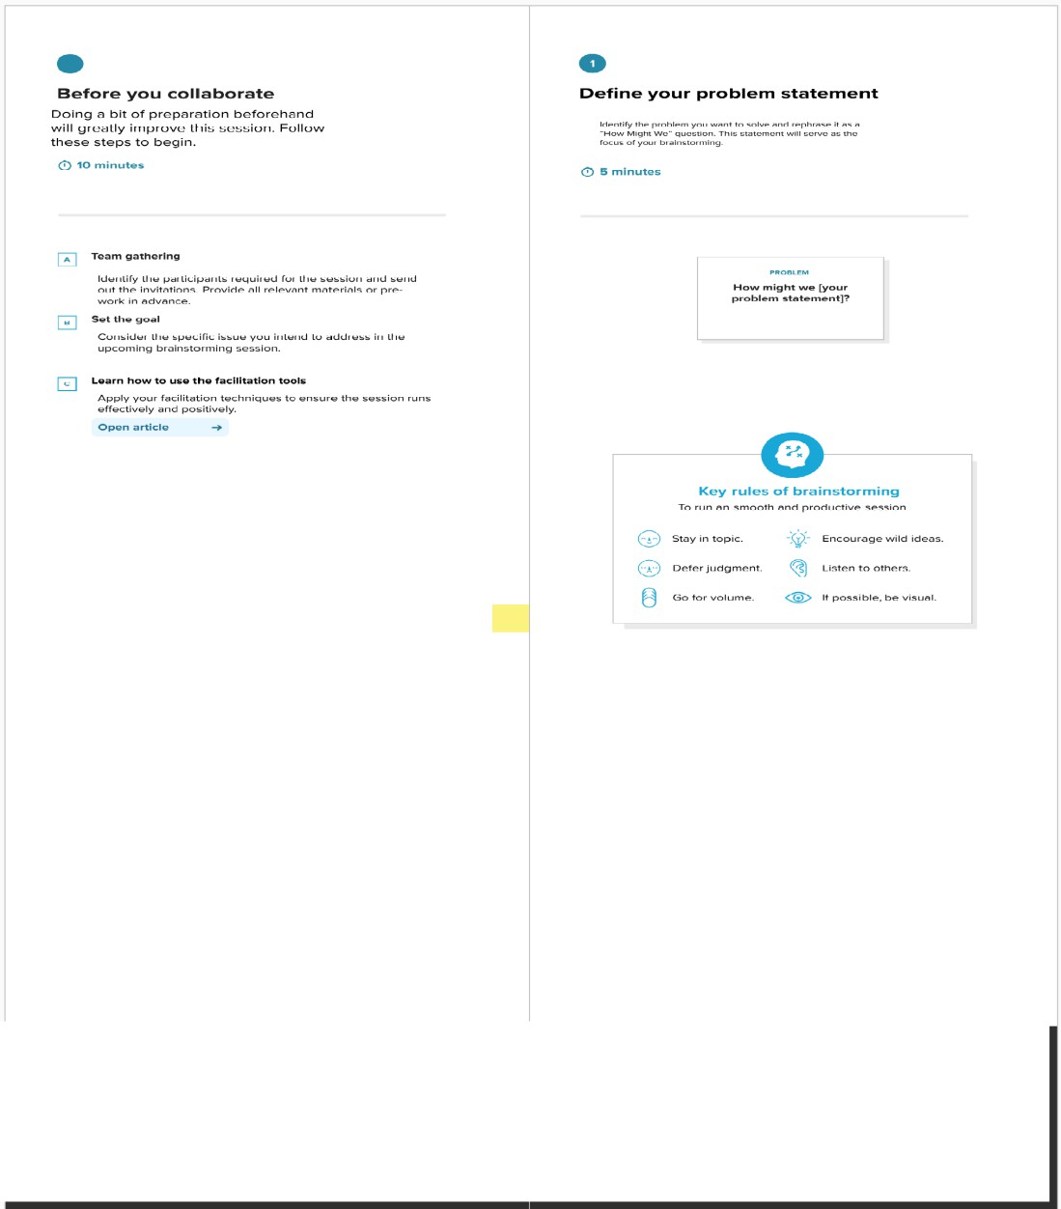

Step-2: Brainstorm, Idea Listing and Grouping

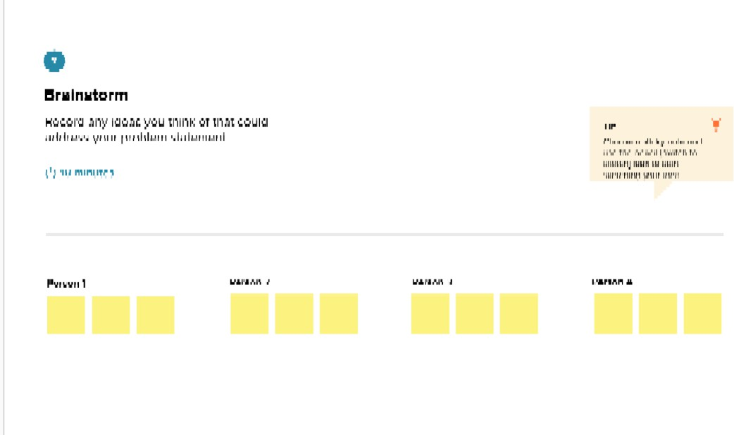
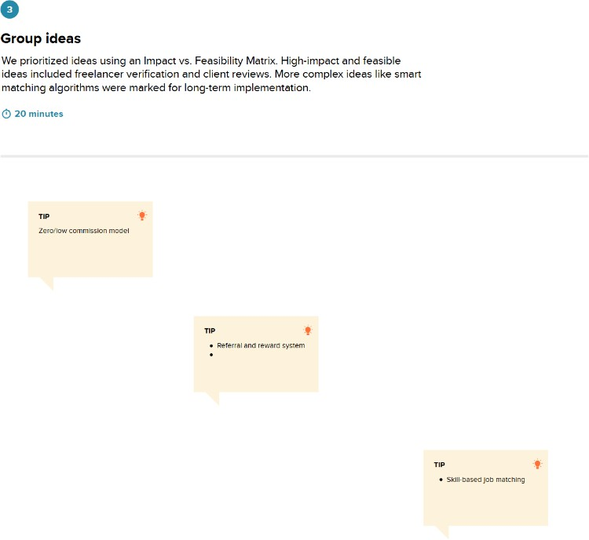

Step-3: Idea Prioritization

